Nexus Aquarium

|  |  |  |
| --- | --- | --- |
| Center Name | Aptech Garden | |
| Batch | 2301D | |
| Semester | 1st Semester | |
| Faculty | Sir Azhar Ghafoor | |
| Project Name | Nexus Aquarium | |
| Serial No. | Enrollment | Student Name |
| 1 | 1445240 | M.Musharaf Wahab |
| 2 | 1444475 | Ali Muhammad |
| 3 | 1447514 | Imran Mala |

Acknowledgement

The first, we would like to express my special thanks of gratitude  
to my teacher SIR AZHAR who helped a lot in finalizing this  
project within the limited time frame, valuable counselling and  
assistance for the accomplishment of this project.  
Secondly, we would also like to thanks the e-project team at  
Aptech Head Office, who gave as the opportunity to do this  
interesting and wonderful project about Aquarium Thirdly, we also thank the e-project team for giving this task to us.

*Following are the benefits of this Project*

• *Re-enforcement of skills happens in the experimental  
learning process.*

• *A mentor, ensuring that we do not get drifted, constantly  
guide us.*

• *It gives us a lot of confidence to face an interview as we  
have worked on a project. We can explain virtually  
everything.*

Synopsis

The website's home page serves as a captivating introduction, drawing visitors into the mesmerizing realm of aquatic wonders. Through stunning visuals, informative descriptions, and intuitive navigation, users will be enticed to **Explore further.**

The "About Us" section provides in-depth information about [Nexus Aquarium]. It highlights the aquarium's mission, history, and commitment to conservation and education. Visitors will gain insight into the dedicated team of marine experts and passionate staff who work tirelessly to create a vibrant and sustainable environment for marine species.

The gallery section showcases a captivating collection of high-resolution images and videos, offering a virtual tour of the aquarium's exhibits. Users can marvel at the vibrant colors of coral reefs, encounter majestic sea creatures, and witness the intricate balance of life in various marine habitats. Each image is accompanied by detailed descriptions, allowing visitors to learn about the unique characteristics and behaviors of the showcased species.

To encourage visitor engagement and gather valuable feedback, we have included a user-friendly feedback form. Visitors can share their experiences, suggestions, and observations, fostering a sense of community and involvement.

Through this comprehensive and visually captivating website, we aim to inspire curiosity, instill a sense of wonder, and promote environmental awareness about the fragile and awe-inspiring world beneath the ocean's surface. Join us on a virtual journey as we dive into the depths and discover the beauty and importance of marine life.

Problem definition

Nexus Aquarium is located in city of Washington, which is the one of well known place for tourism. Aquarium is very huge and comprises of marine life animals and they are fed and breeding. It is the big centre for organizing the school events for the purpose of study and so on. For the children to visit an aquarium is big thing as they love to sea creatures. The organization wishes to make a website for the aquarium for which they have contacted you.

Requirement Specification:

The Web site is to be created based on the following requirements.

1. The Home page must have well defined logo and image of the sea creatures.
2. Apart from home link, other links such as gallery section, certain information about animals (marine life animals) they have.
3. Contact details must be added.
4. Timing and location must be stated in the website
5. Events (separately for children) must be stated in the website with the proper schedule and details.
6. Online booking of event (Dummy page where information must be entered, and validation checking must be done)
7. Images of the aquarium location (site seeing must be included)
8. Navigation must be maintained smooth.
9. Color combination must be precise and uniformity must be maintained.
10. Categorization of the marine life animals and there different species information should be shown in tabular form.
11. Feedback form (dummy) should be provided.

Site map

Layout

1. Home Page

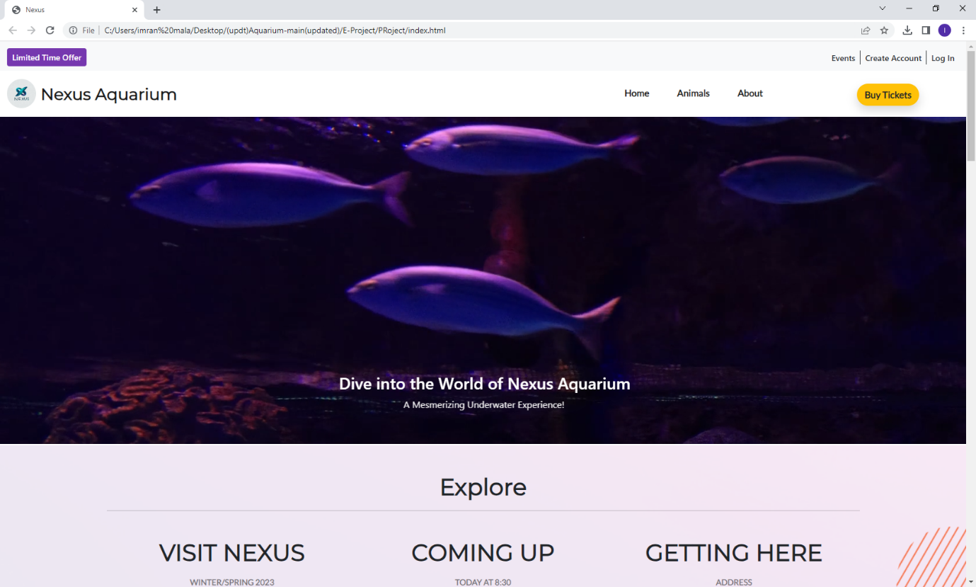

2. Explore Section

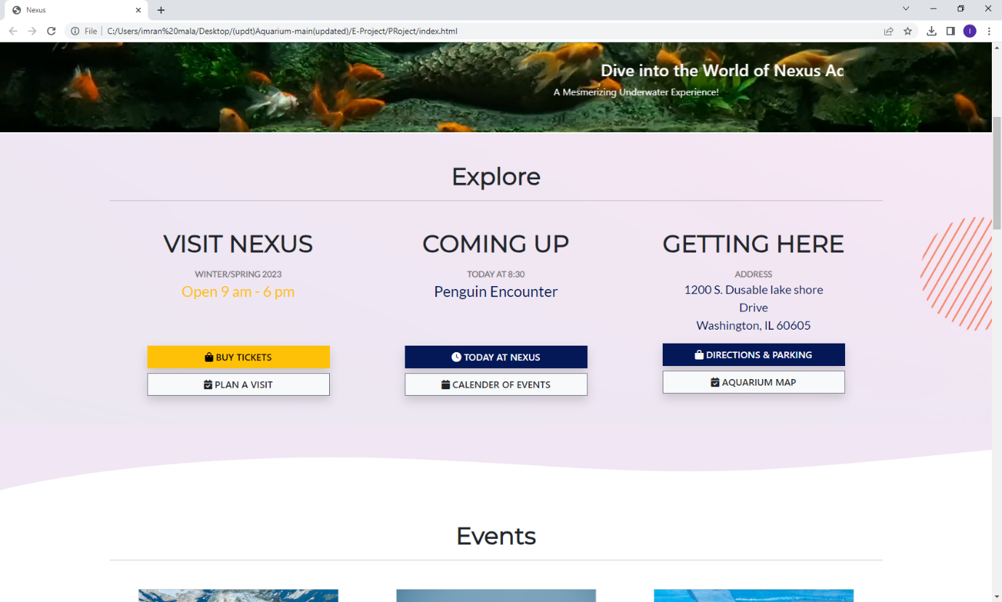

3. Events Section

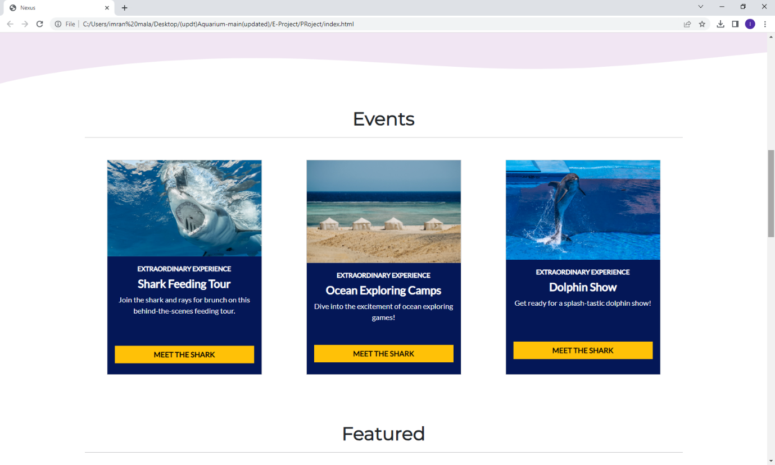

4. Featured Animals

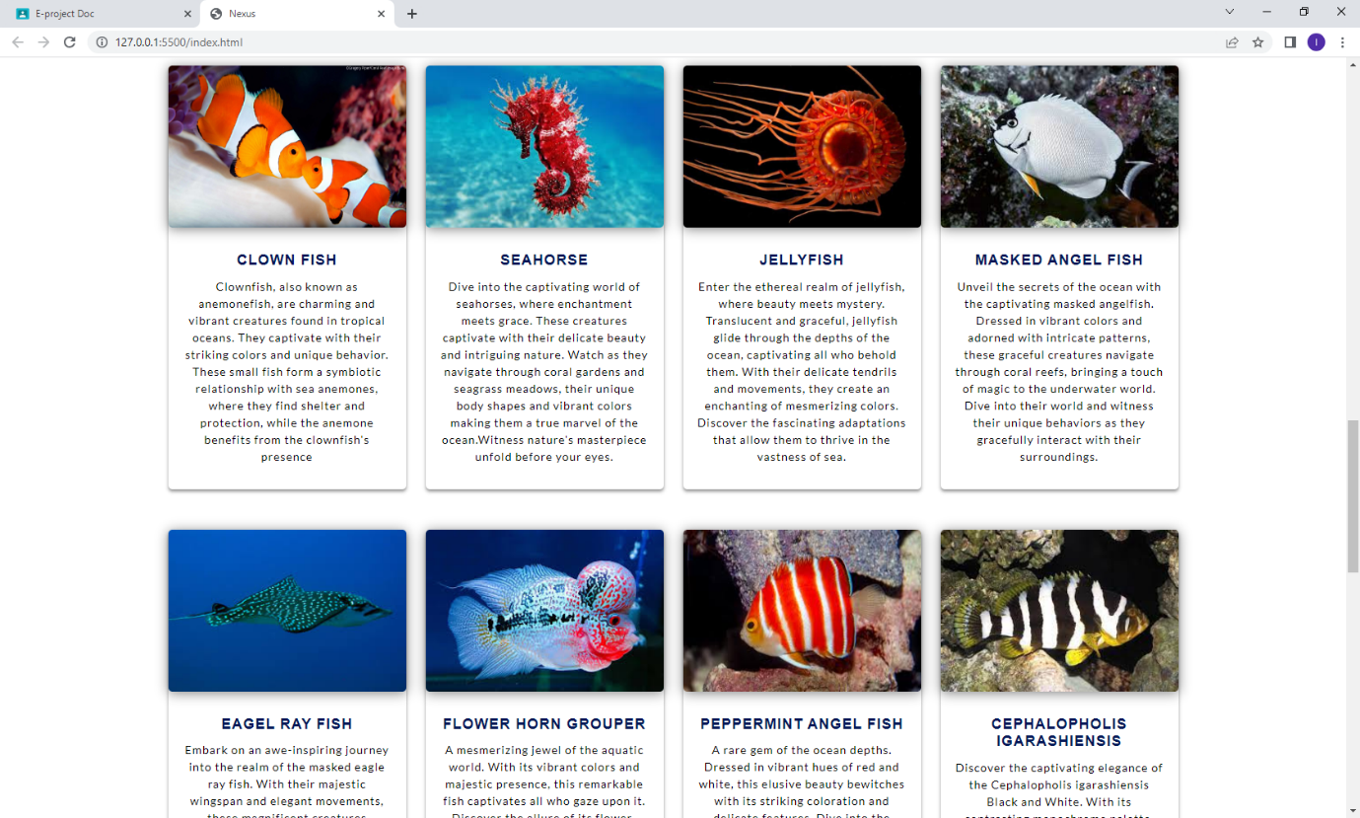

5. Feedback Form

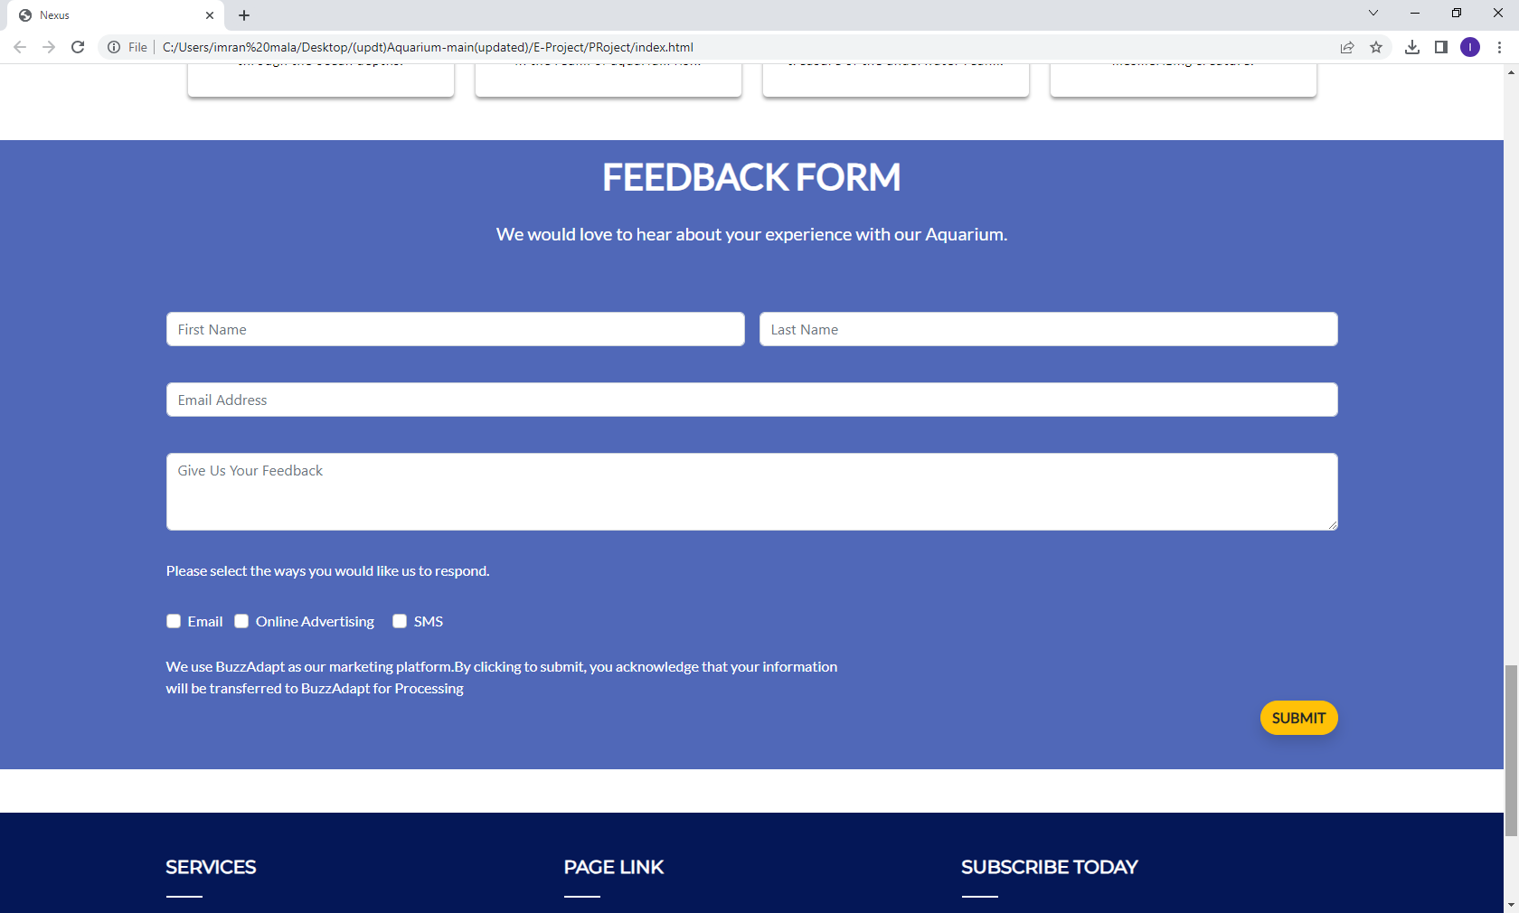

6. Animals Gallery

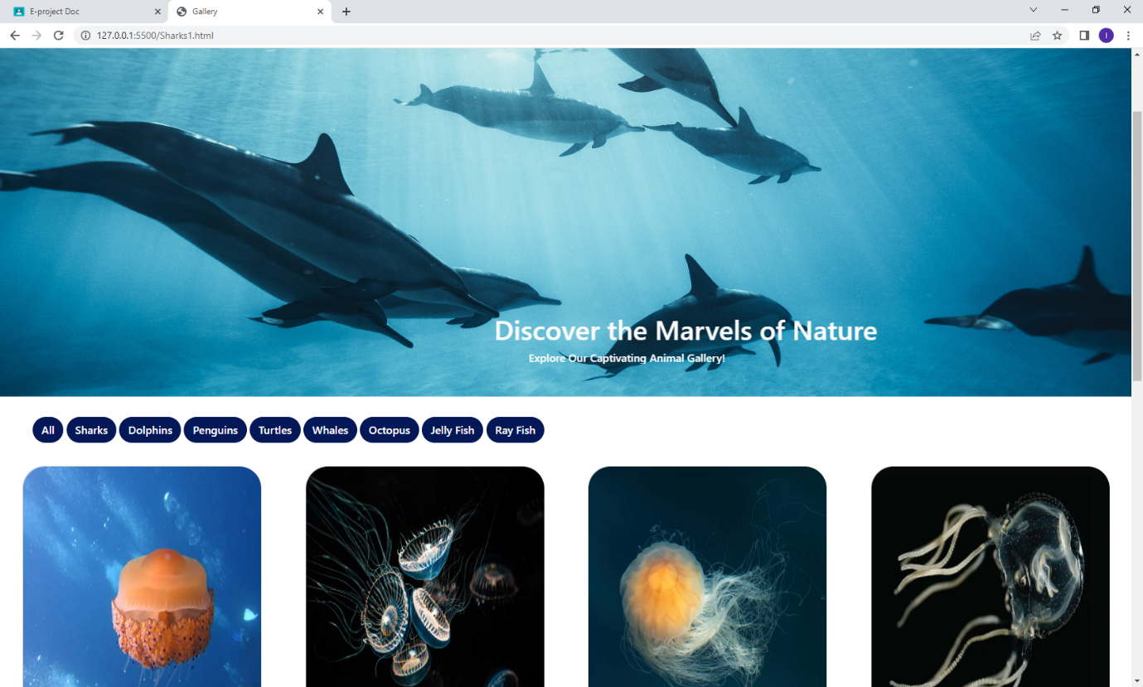

7. About Us

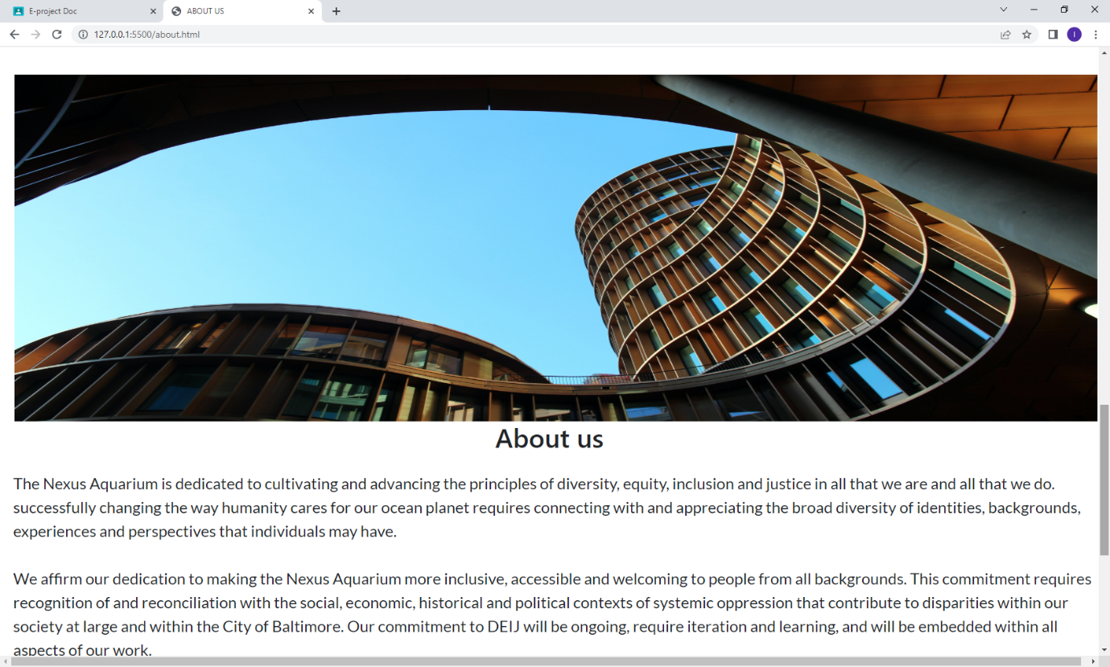

8. Ticket Page

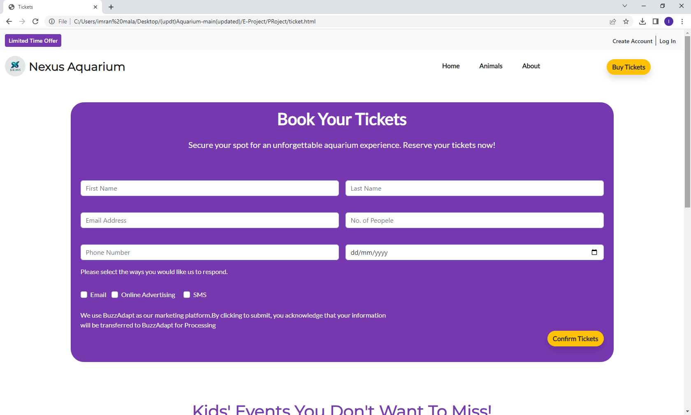

9. Special Events For Kids

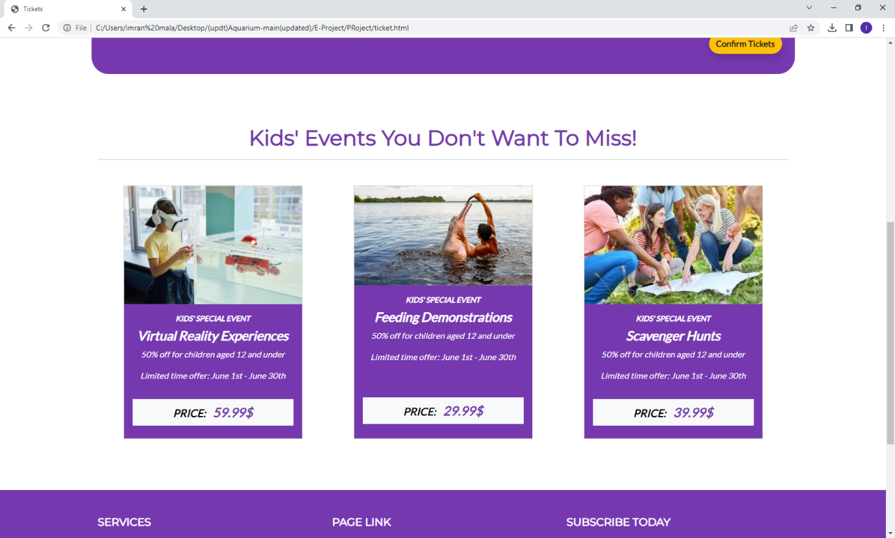

10. Footer

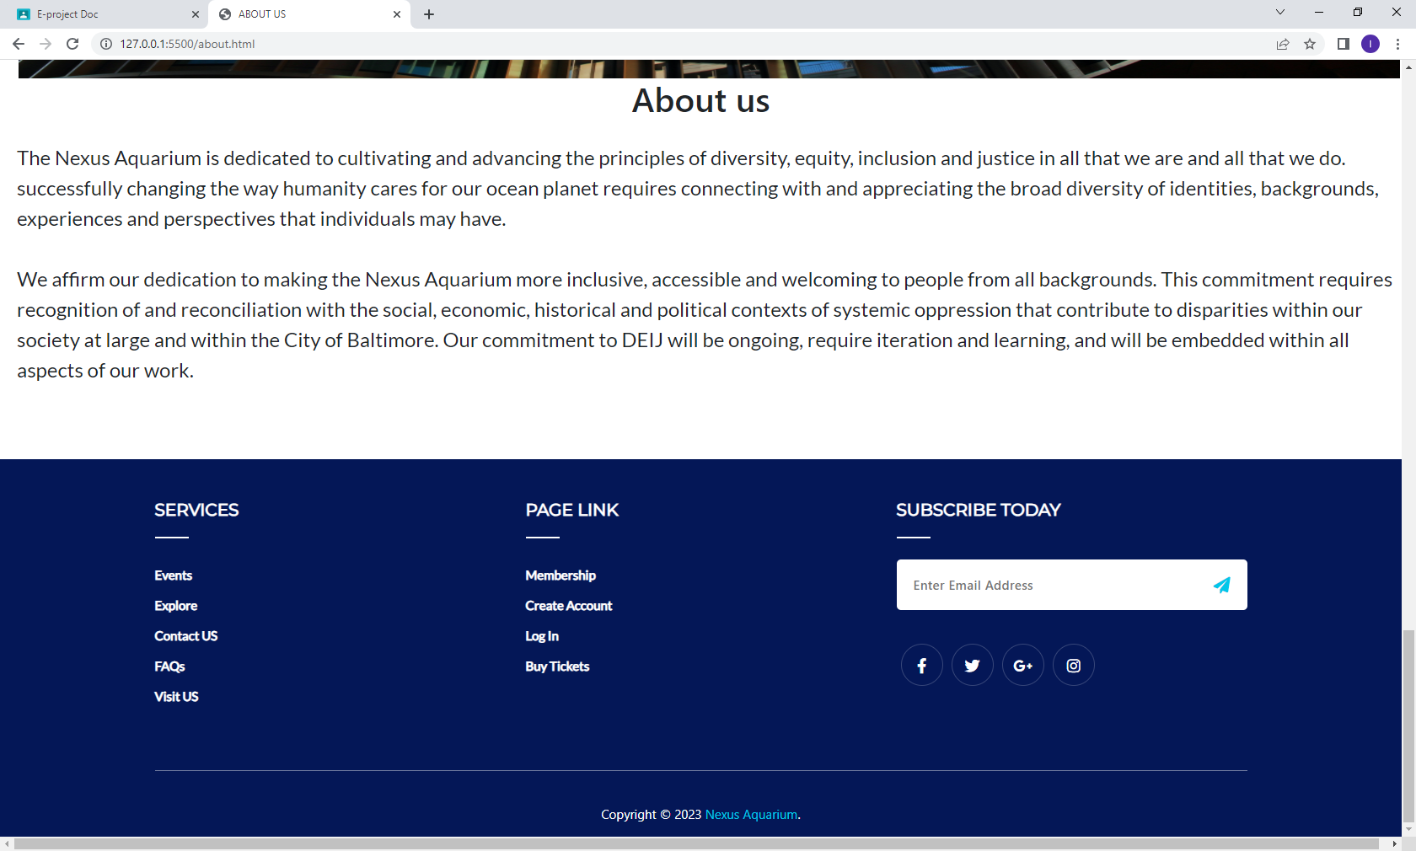

Task Sheet

|  |  |  |
| --- | --- | --- |
| No. | Tasks | Student Name |
| 1 | **About Page** | **M.Musharaf Wahab** |
| 2 | **Animals Page** | **Ali Muhammad** |
| 3 | **Home/Ticket Page** | **Imran Mala** |
| 4 | **Documentation** | **All** |

The End.